**Vnet To Vnet Connection**

1.Create 2 Vnets with different Regions in two Different Resource groups

* I created 2 Resource groups

Nihapriya(south india) And Priya-rg(south central US)

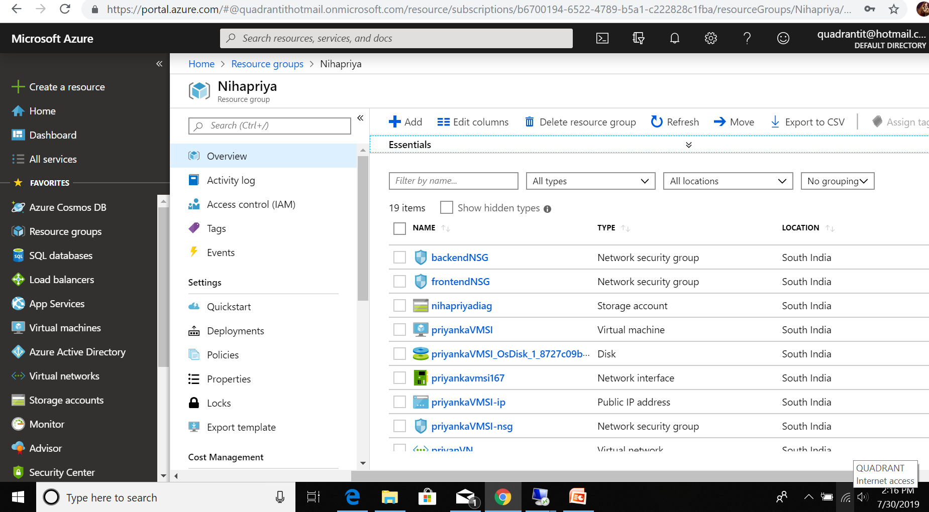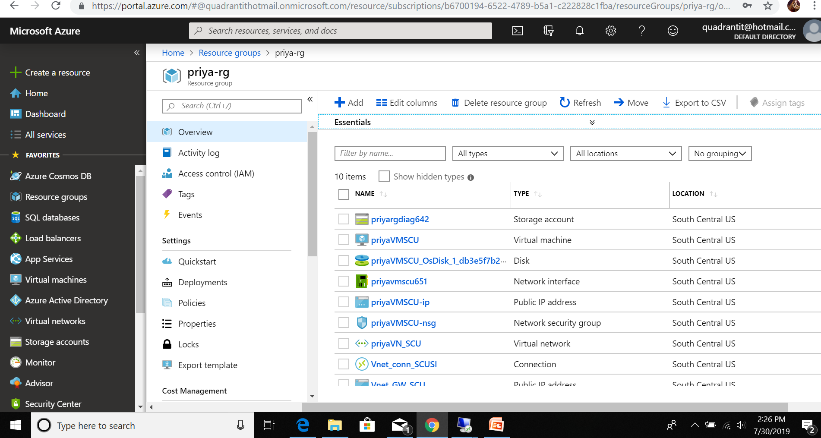

2.i created Vnets

* PriyaVN_SCU in Priya-rg group. In that I created subnet Gateway

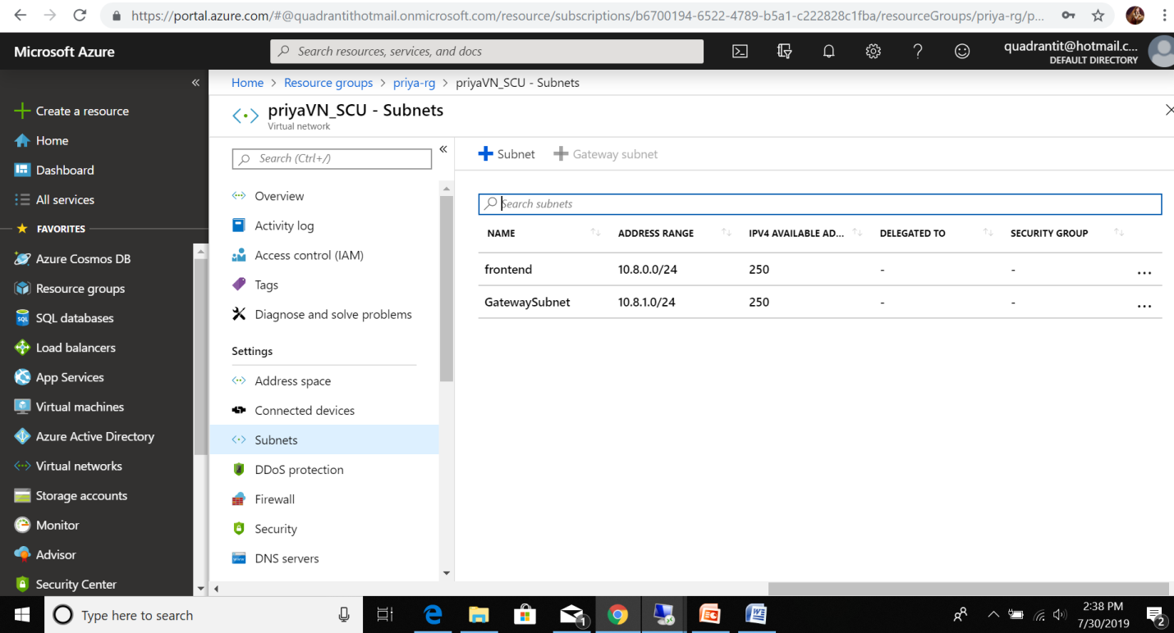

* priyanVN in Nihapriya group . in that I created subnet gateway

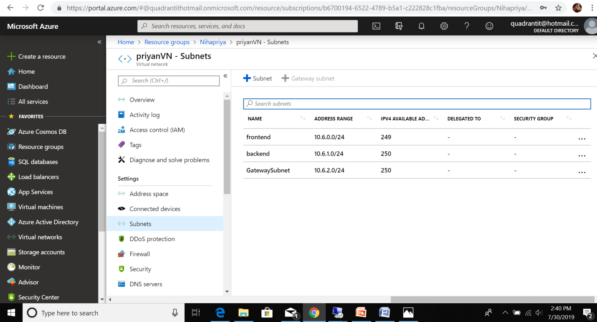

3. I created virtualnetwork Gteways

* Vnet_GW_SI for south india region in Nihapriya Rg

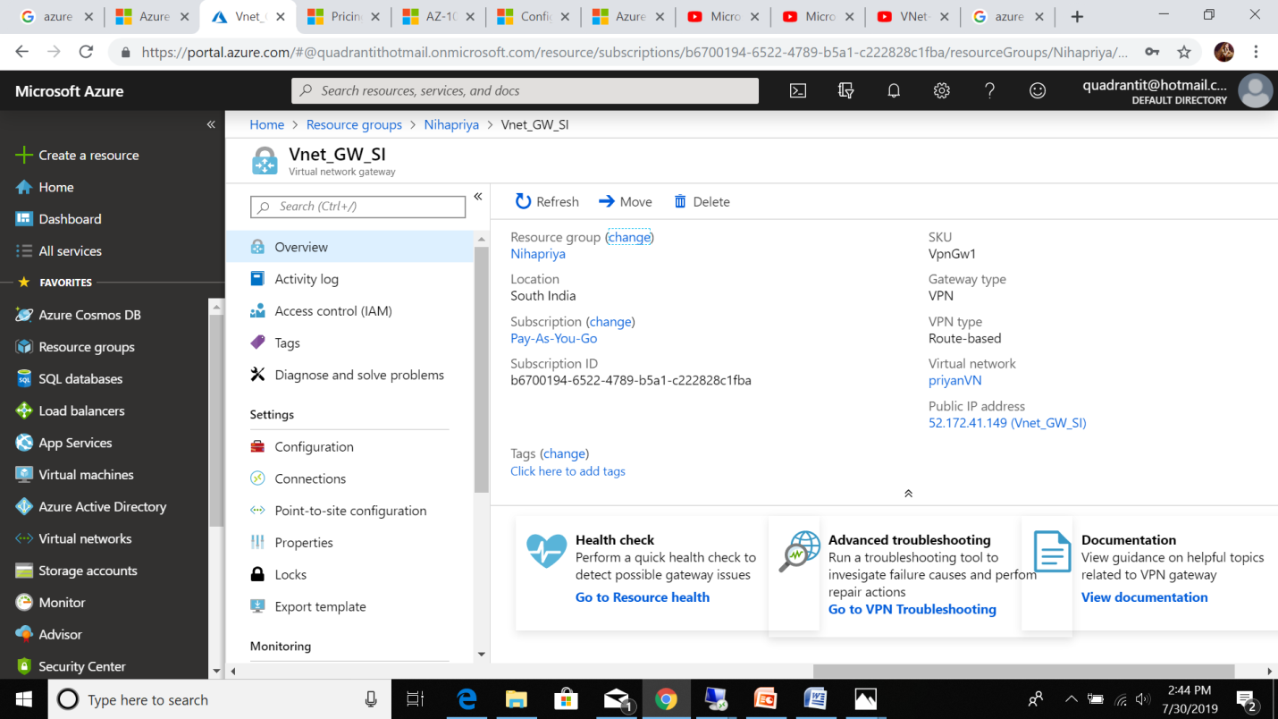

* Vnet_GW_SCU for south central US region in Priya-rg group

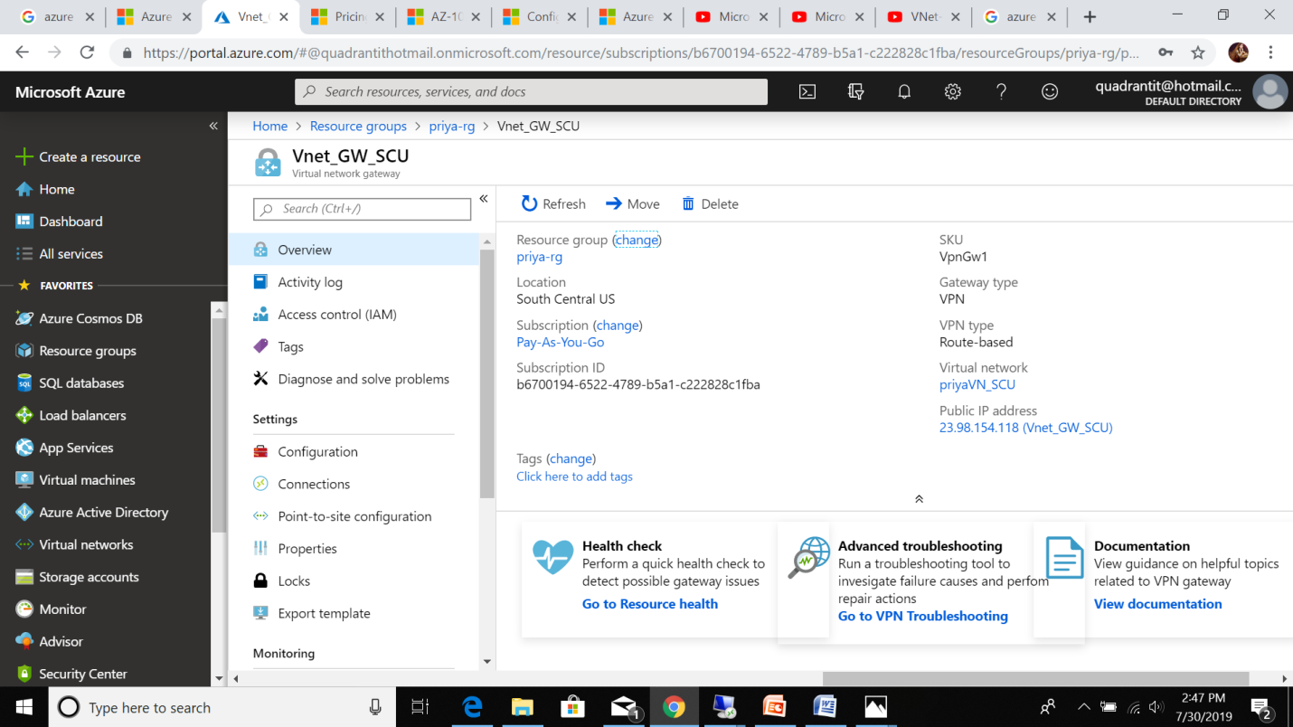

4.after I created Vnet to Vnet peering

* South central US to South india

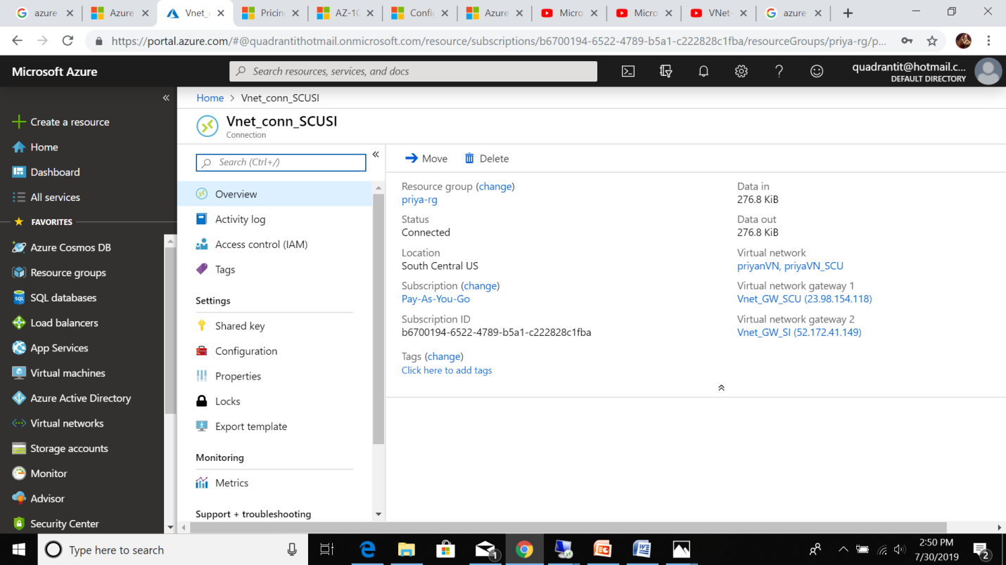

* South india To Sounth Central US

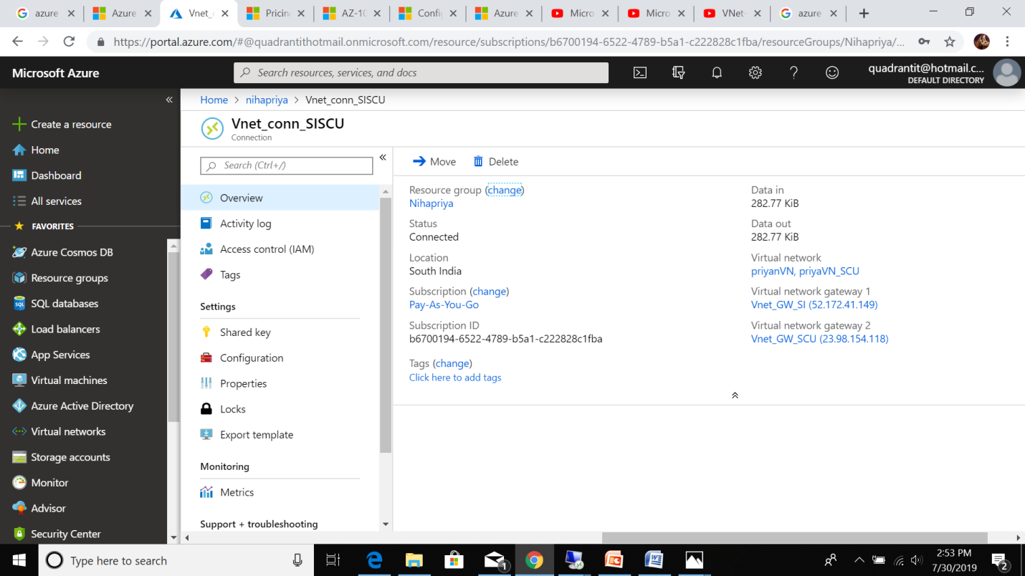

5.After this I created 2 Virtual Machines

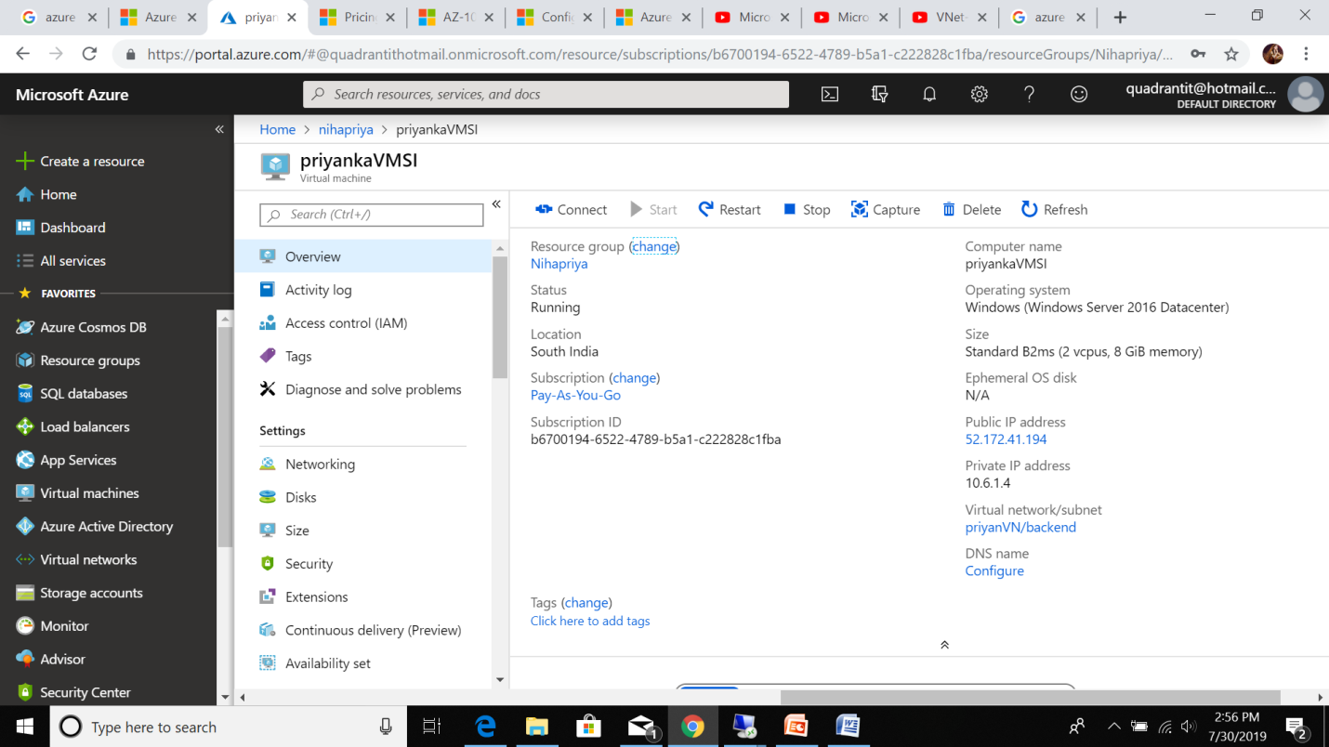

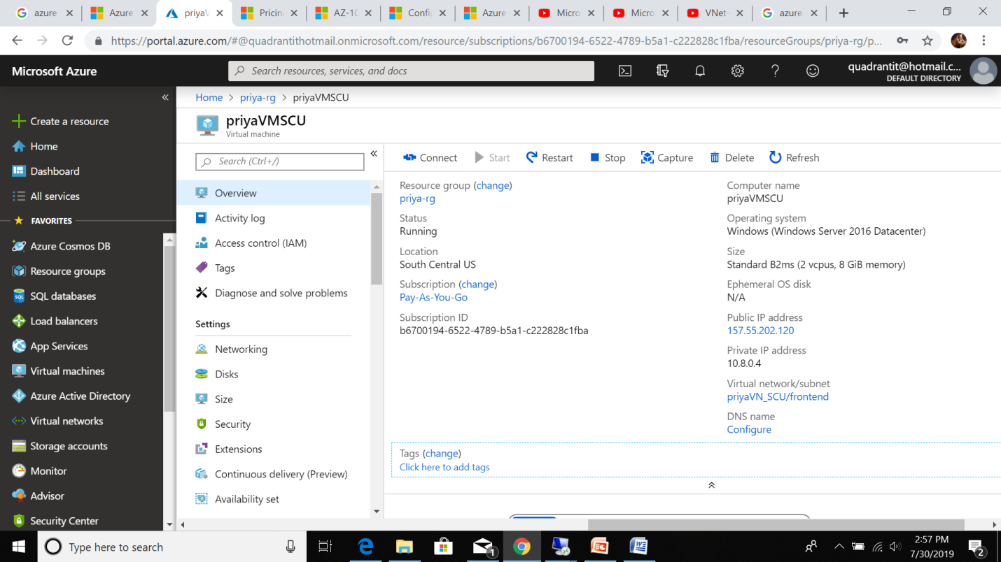

6.I signed into 2 VMS Using RDP file

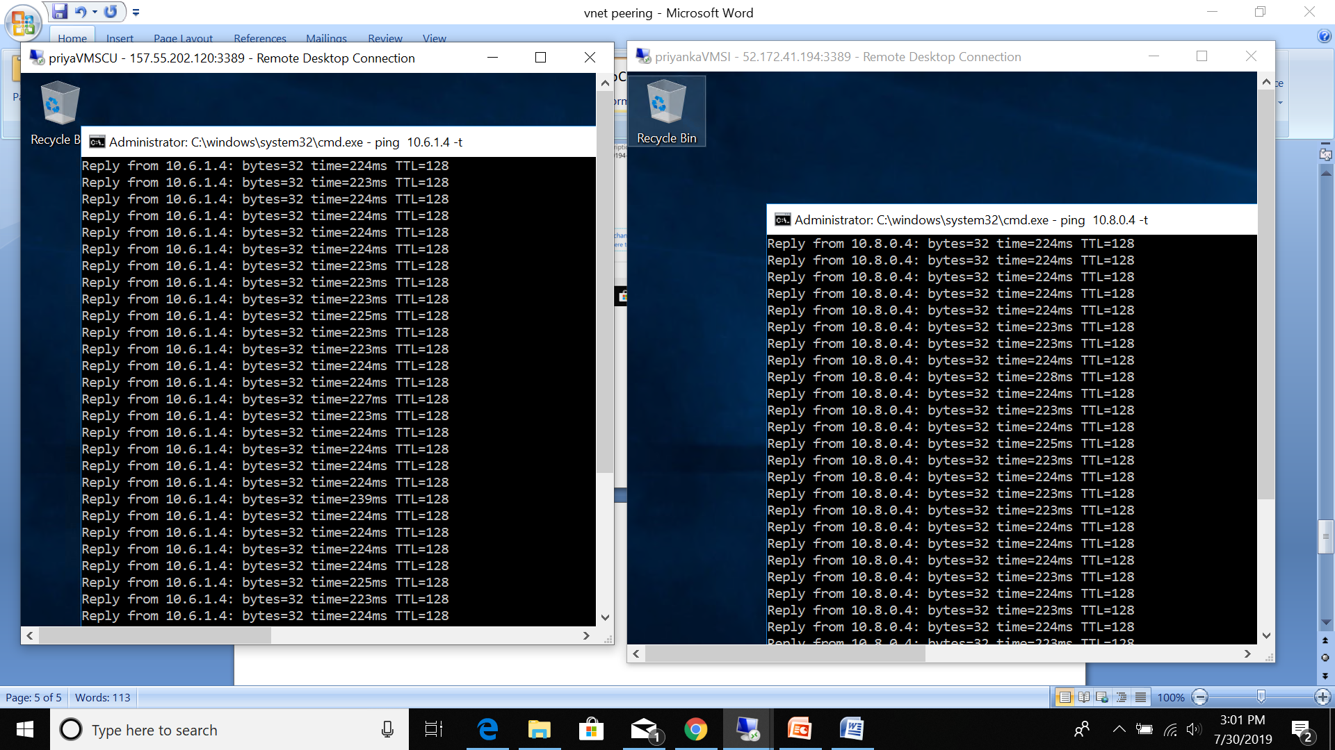

7.turned off the windows firewalls in both vms

8.Vnet to Vnet connections are created.

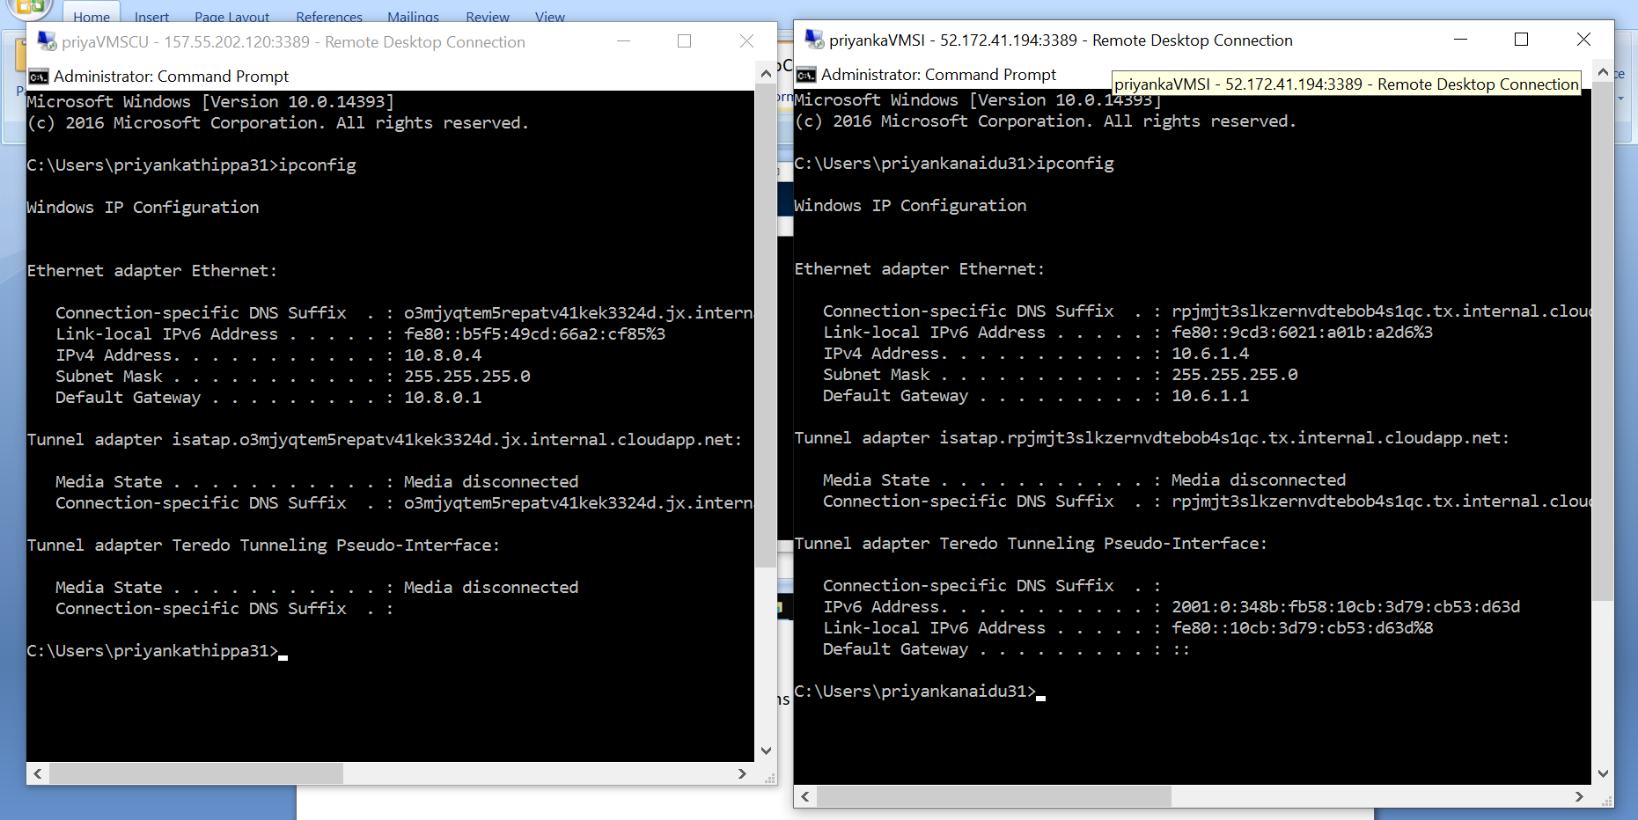

9.one VM to another VM connection Established

